TLEN 5410 – Network Management and Automation

Lab 9

NETCONF - Network Configuration Protocol

University of Colorado Boulder

Interdisciplinary Telecom Program

Professor Levi Perigo, Ph.D.

# Summary

The Network Configuration Protocol (NETCONF) provides mechanisms to install, manipulate, and delete the configuration of network devices. It is a standard defined by IETF [RFC 6241](https://tools.ietf.org/html/rfc6241). YANG is its data modeling language. NETCONF aims to help remove the time, cost and manual steps involved in network elements configuration. The objective of this lab is to provide an overview of NETCONF and its operations.

Students are encouraged to expand on the topics for additional learning and experiments.

# Objective 1: Getting started

1. Create the below topology in GNS3 on the NetMan VM.
2. Please use the router image c7200-15.2 image for this lab. [The c3600 image does not support NETCONF.]

If you do not have this image installed - open Firefox on the VM, download it from this GDrive link- [https://drive.google.com/file/d/16iLceRNNAIhmsr9-UZnBUsVC0Ui9FtzX/view?usp=sharing](https://drive.google.com/file/d/16iLceRNNAIhmsr9-UZnBUsVC0Ui9FtzX/view?usp=sharing%20), and add it to GNS3.

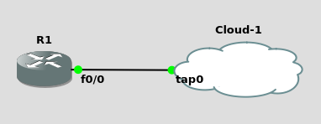s

1. Refer this link to configure NETCONF over SSH on the router - <https://www.cisco.com/c/en/us/td/docs/ios-xml/ios/cns/configuration/15-mt/cns-15-mt-book/netconf-sshv2.html>

Apart from SSH, which other secure transport methods are supported by NETCONF? [**5 points**]

Apart from SSH, NETCONF also supports Transport Layer Security (TLS).

1. Establish a NETCONF session with the router. Paste screenshots of the commands – **show netconf session** and **show netconf counters** on the router indicating a successful NETCONF session. [**20 points**]

First of all, I need to enable ssh:

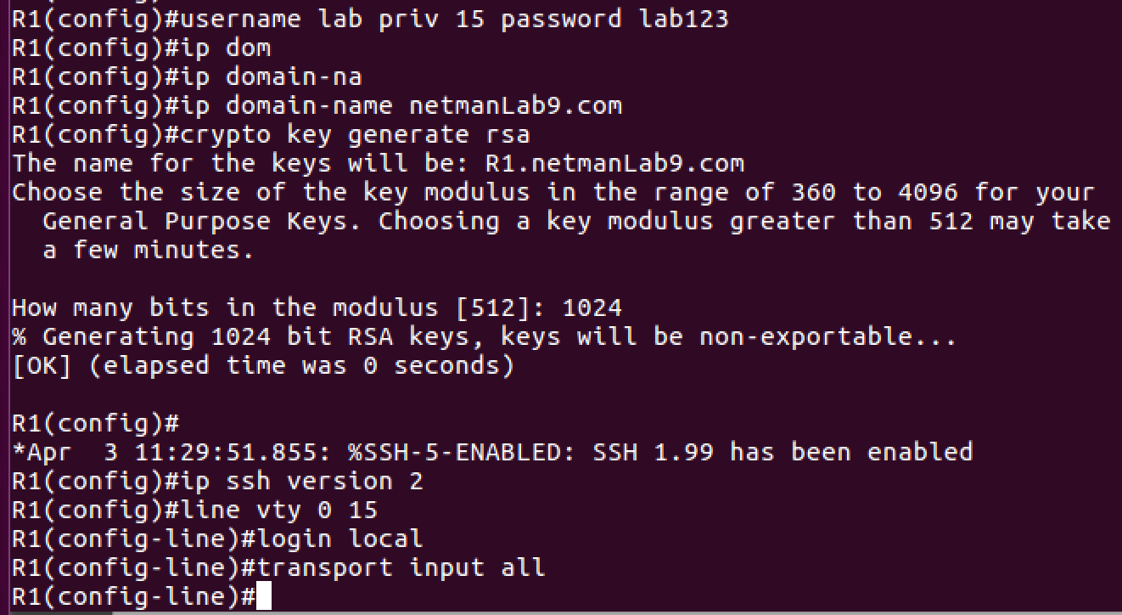

Then, enable the f0/0 with the same network ip address on R1,

Ssh to R1 with netconf:

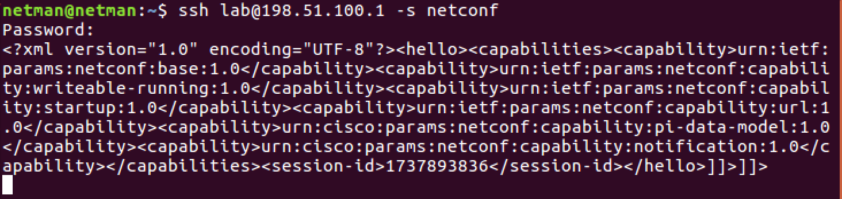

Config netconf on R1:

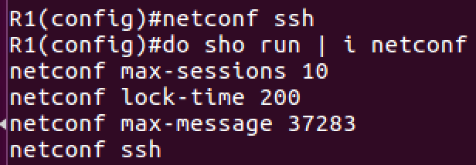

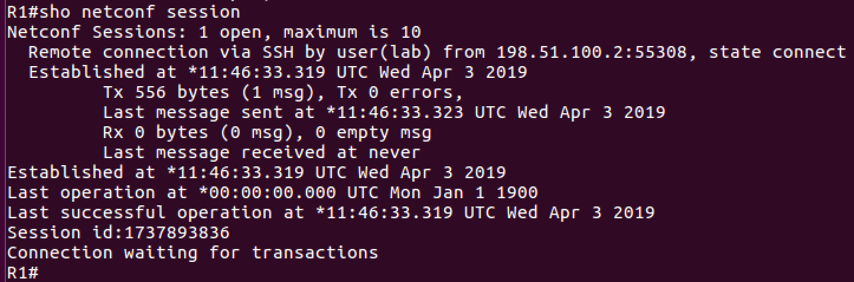

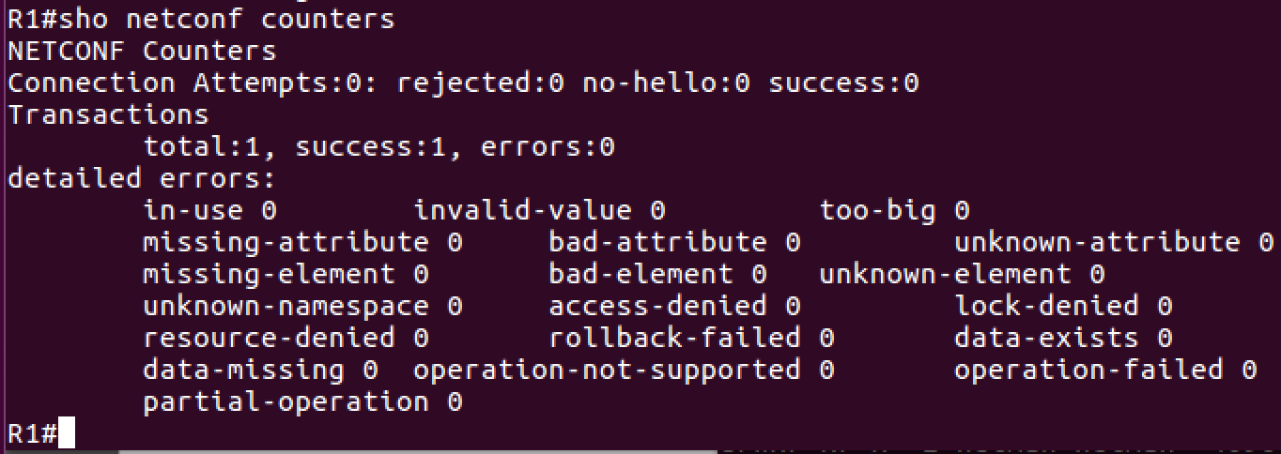

1. Using NETCONF <get-config> message, get the current running configuration of the router. Paste screenshots of the messages. [**5 points**]

Note: There is a crazy bug that class VM is NOT working for unknown reason. I have to install GMS3 on my Mac instead of class VM….

First of all, when you establish the connection, you need to send back hello to the server. In this case, copy what server sends to you and remove everything between <session-id> and </session-id>

Then, enable the notification:

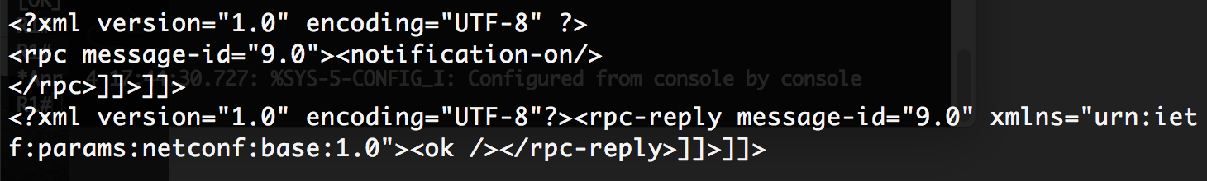

Now, you can send <get-config> request of XML:

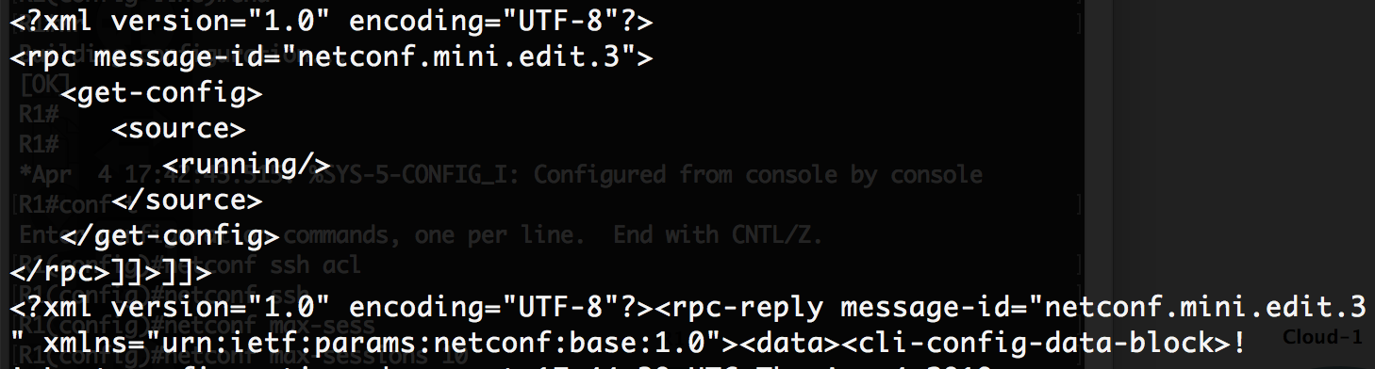

<get-config> response:

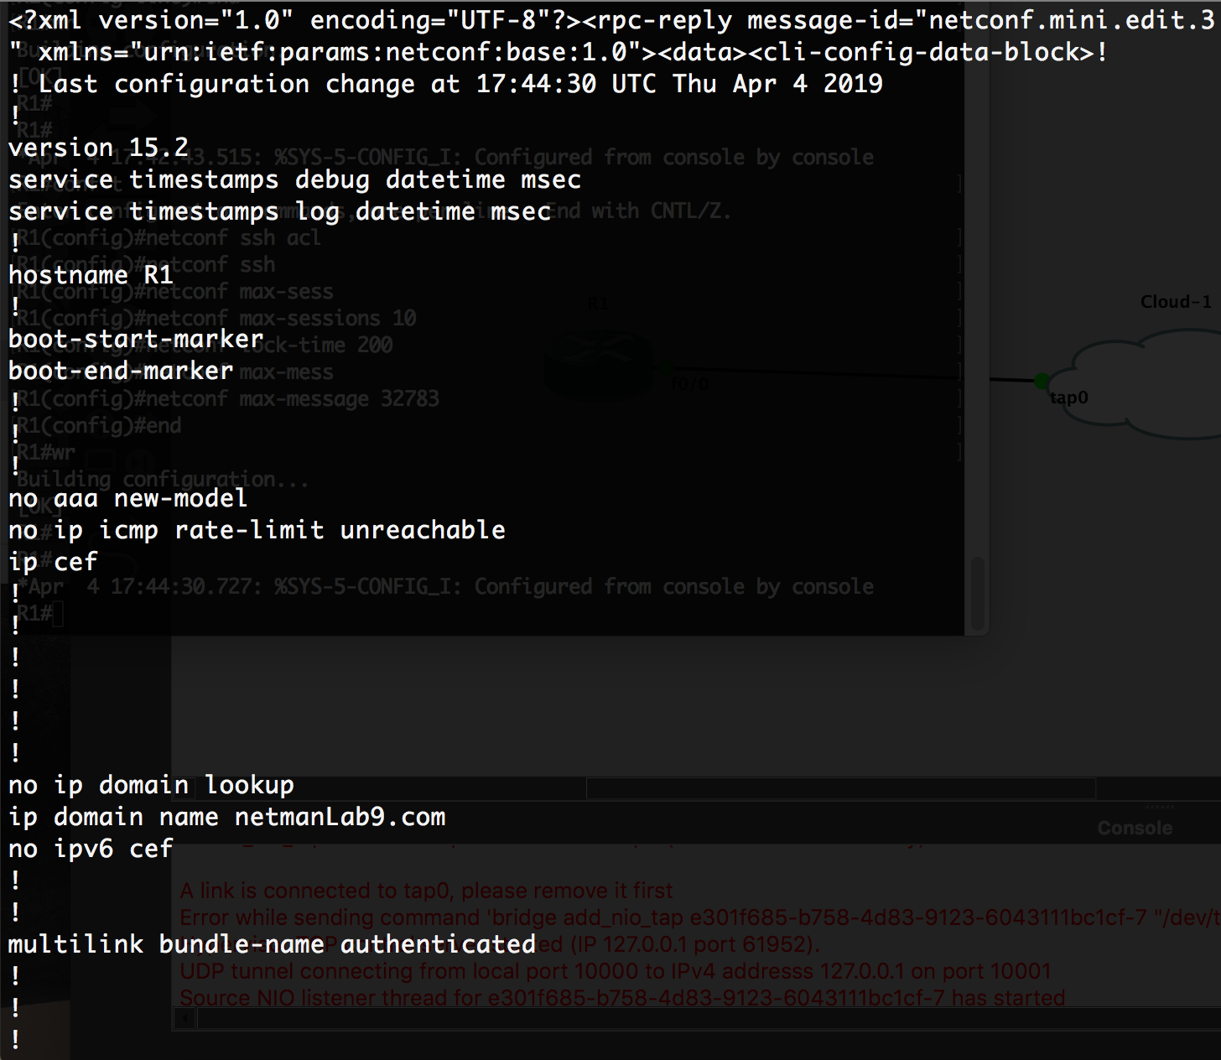

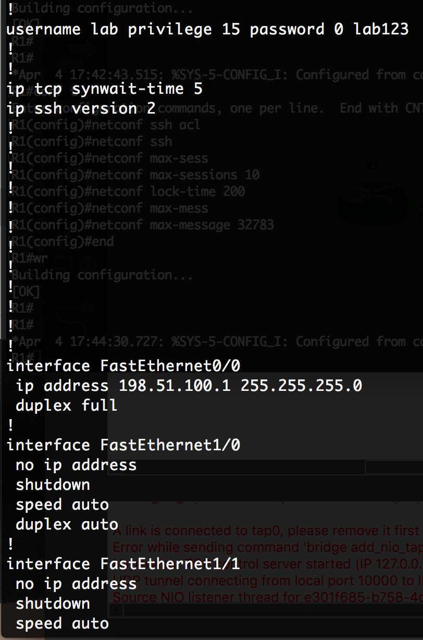

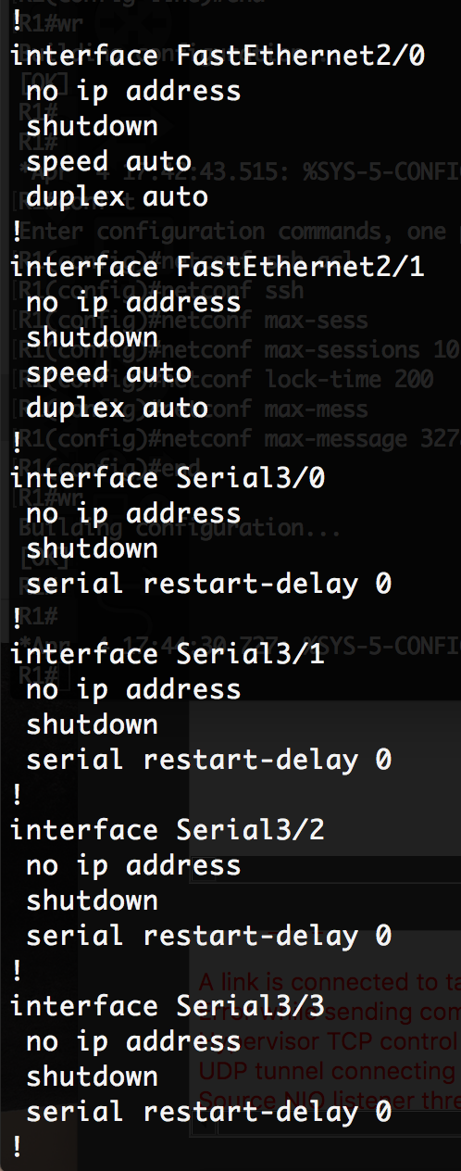

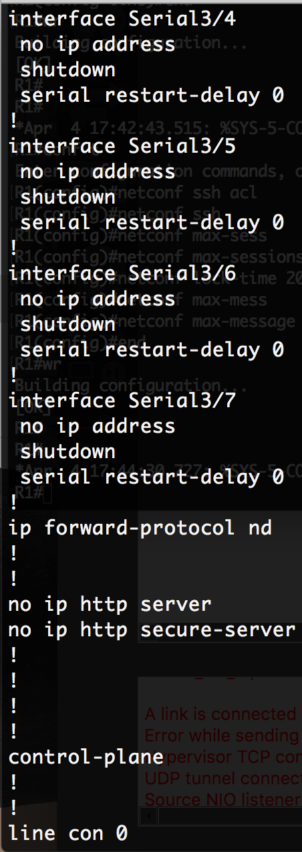

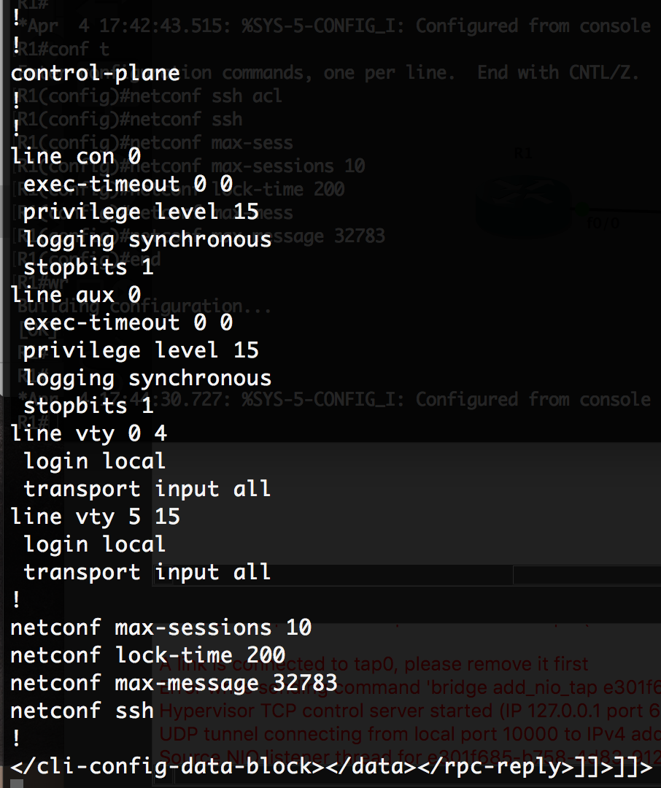

1. Using NETCONF, get the name of the interfaces on the router. Paste screenshots of the messages. [**5 points**]

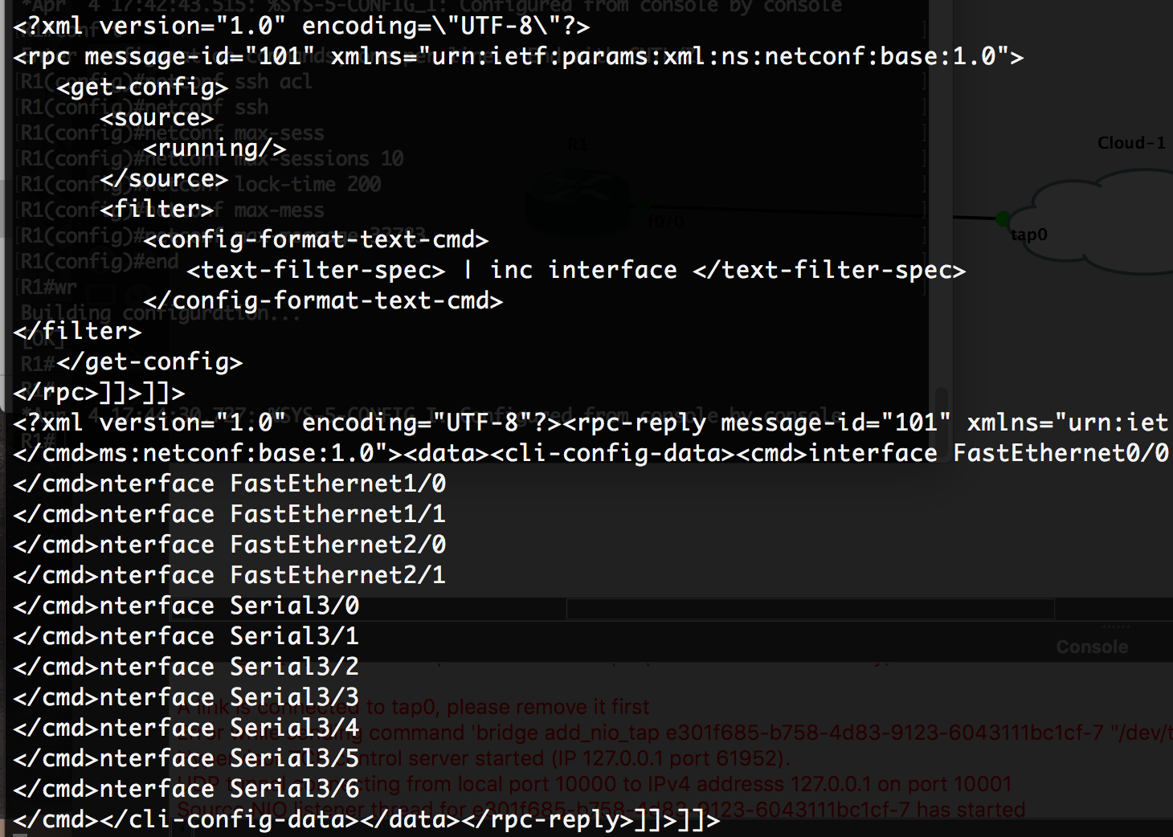

1. Using NETCONF, get the running configuration of the interface FastEthernet1/0. Paste screenshots of the messages. [**5 points**]

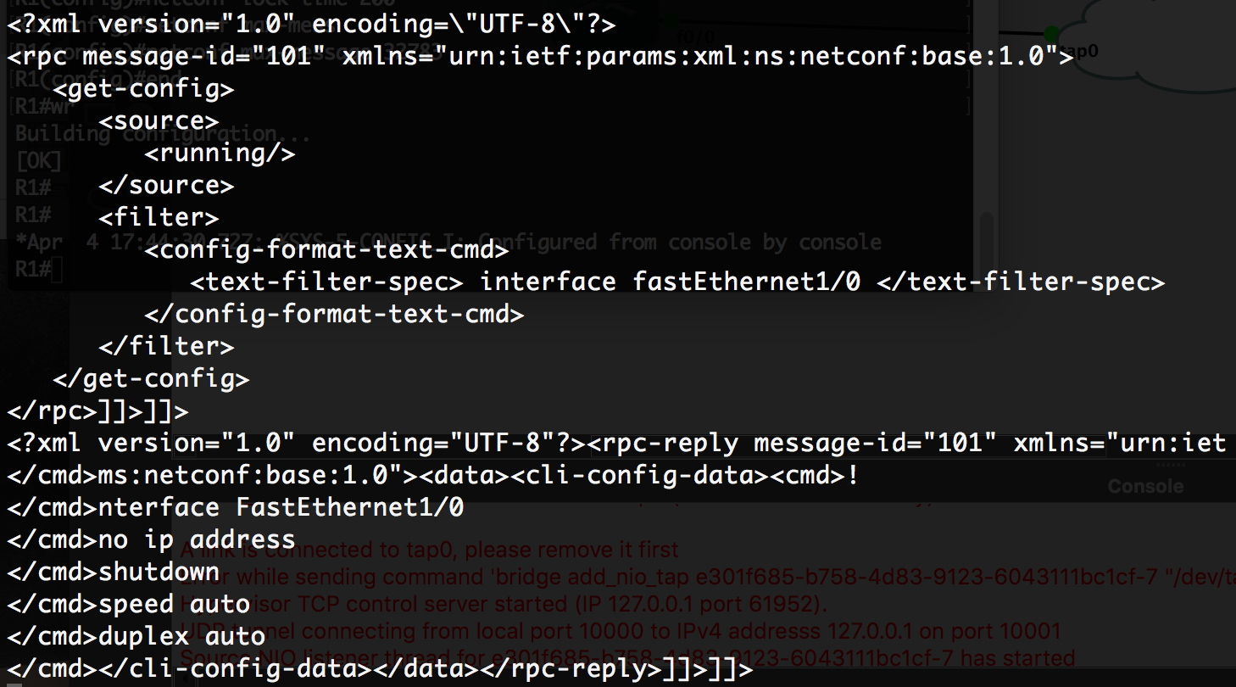

1. Using NETCONF-
   1. Set the hostname of the router to – Lab9Router,
   2. Create a Loopback Interface 10, and
   3. Assign the IP address 10.1.1.1/32 to the interface.

Paste screenshots of the messages. [**10 points**]

<edit-config> request:

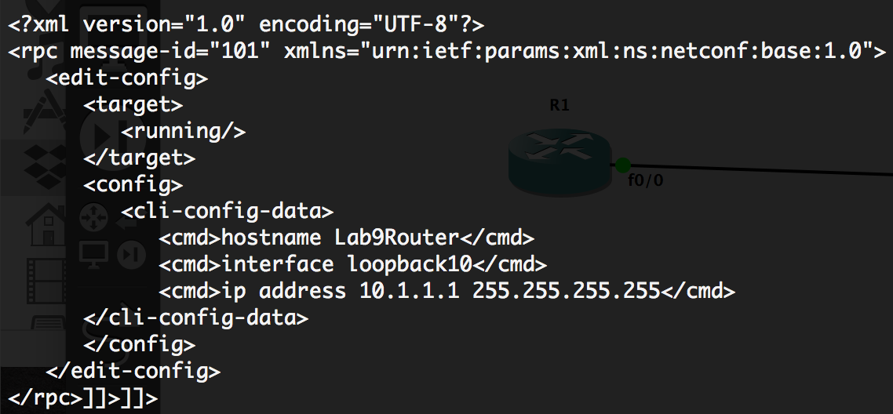

<edit-message> response:

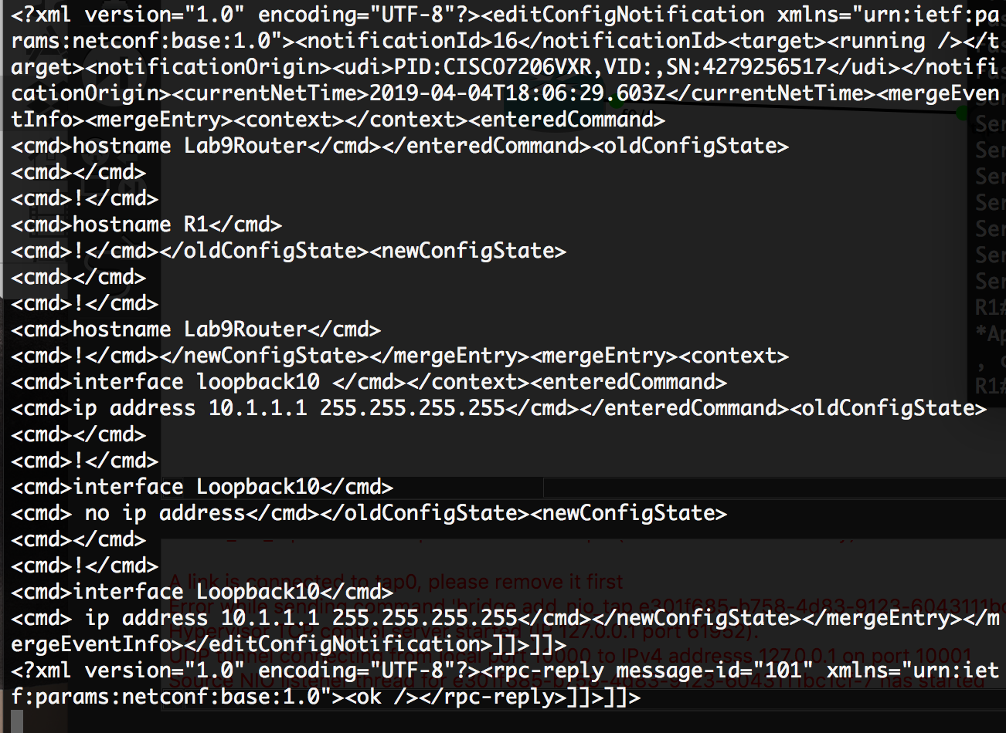

Result on router:

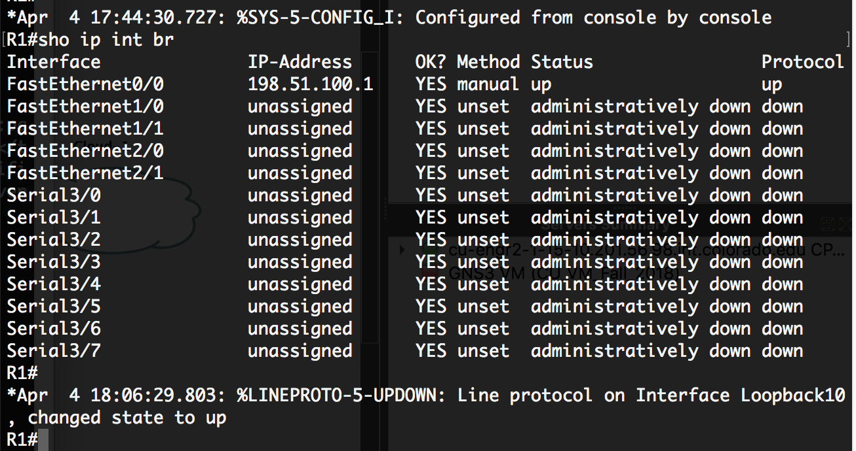

1. Using NETCONF <get> message, get the running configuration of the interface Loopback 10. Paste screenshots of the messages. [**5 points**]

<get> request:

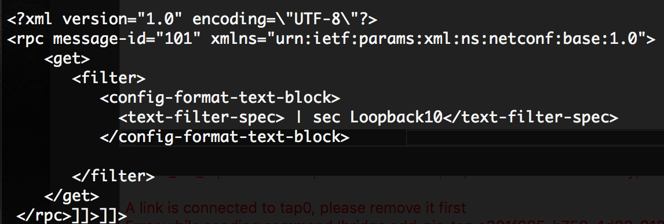

<get> response:

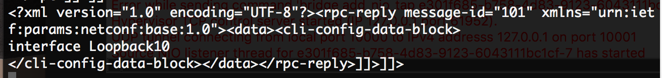

1. Using NETCONF, copy the running-config to startup-config. Paste screenshots of the messages. [**5 points**]

Request:

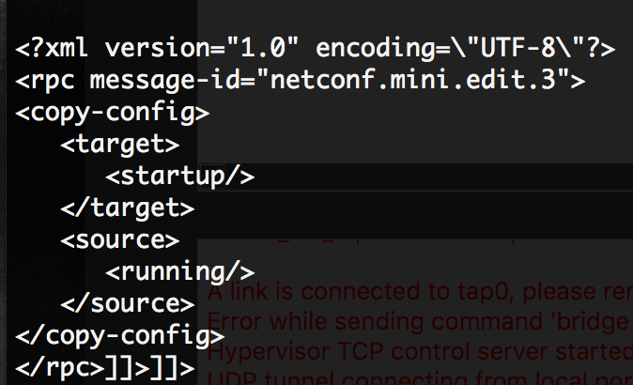

Response:



1. How do you check if the router supports candidate configuration datastore? [**5 points**]

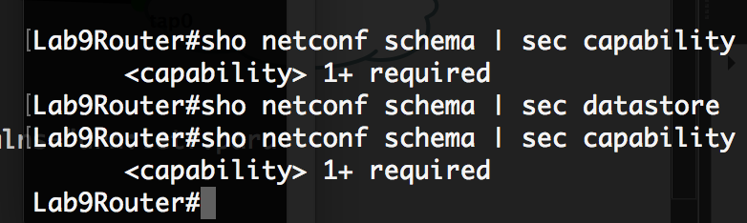

# Objective 2: NETCONF and Python

[ncclient](https://pypi.python.org/pypi/ncclient) is a Python library for NETCONF clients. It offers an intuitive API and makes writing network management scripts easier.

1. Install ncclient Python library on the VM.
2. Create the below topology in GNS3-

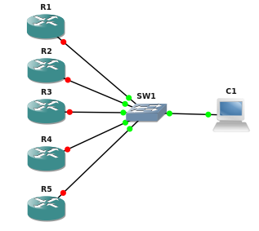

1. The configuration to be implemented is present at this link - <http://172.20.74.202/lab9-obj2-conf.txt> [Accessible only from the campus network.]
2. The objective is to implement the configuration using a Python script and the ncclient library.
3. Implement this objective using the shortest (i.e. the most automated) method you can think of.
4. The final output should be a table printed out, similar to the config file, with the details fetched from the routers.
5. Mention the steps you followed to complete this objective. Submit the script along with your submission. [**70 points**]

Before doing this objective, remove a command like (if you have any):



This command prevent you to get output from get_config() in ncclient:

1. I need to configure all routers with SSH: username, password, domain-name, crypto key, ssh version 2

2. Give a IP address to interface f0/0 so the VM can connect to it on each router

3. Run Python script

Inside of my script:

* Read json file (lab9_obj2_requirement.json)
* Create a XML config and passing the parameters into the interface XML
* Create a XML config and passing the parameters into the OSPF XML

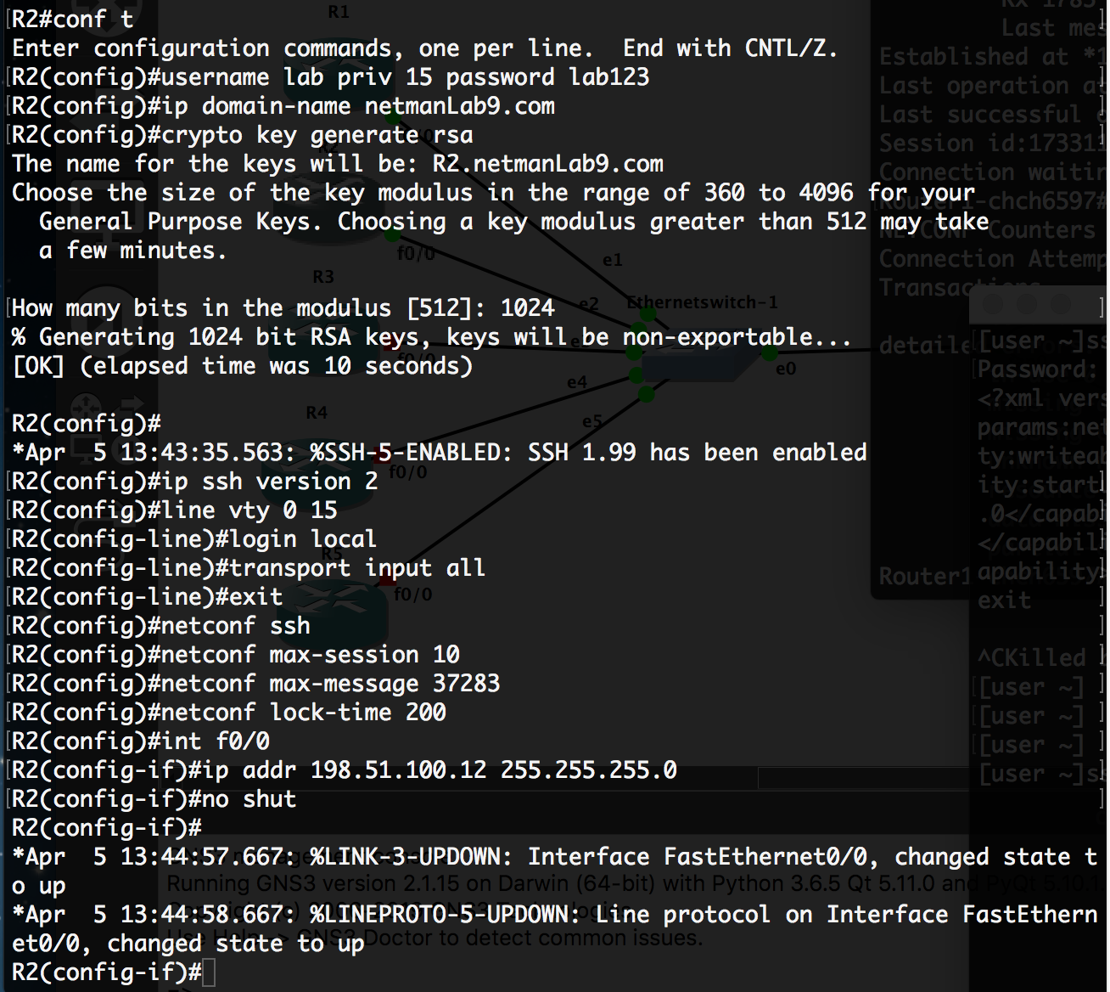

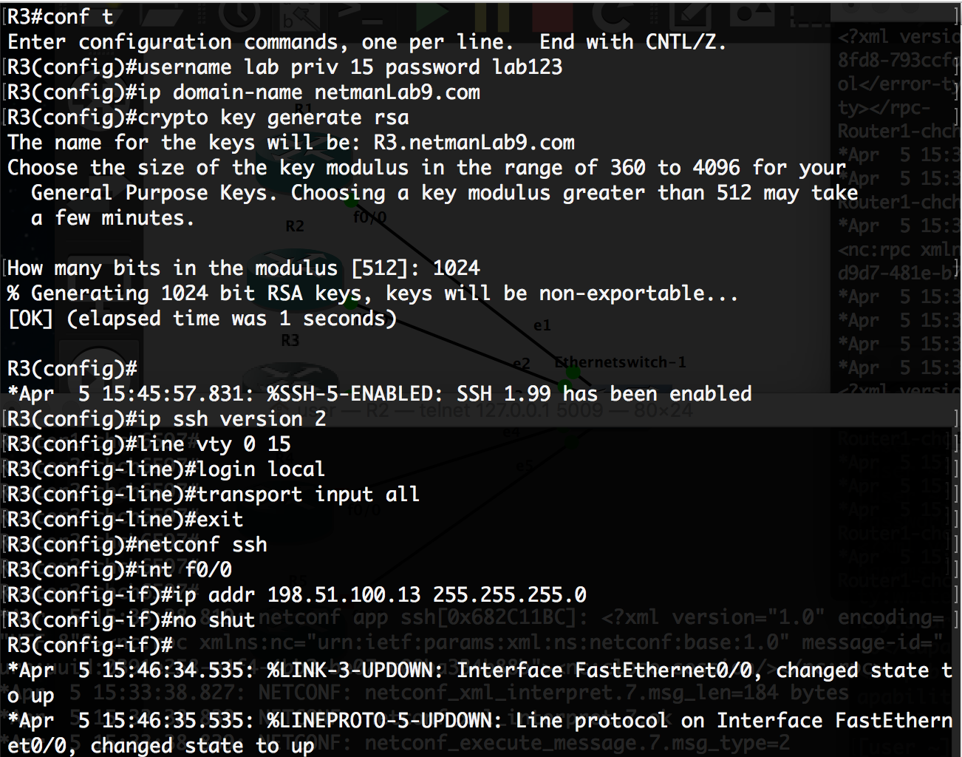

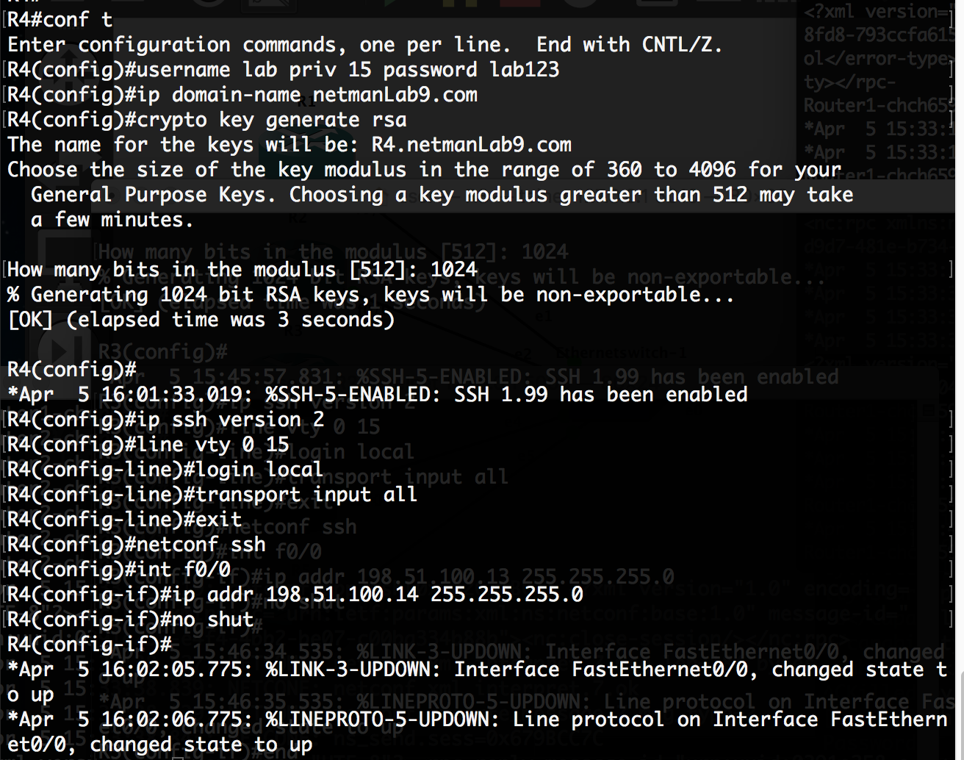

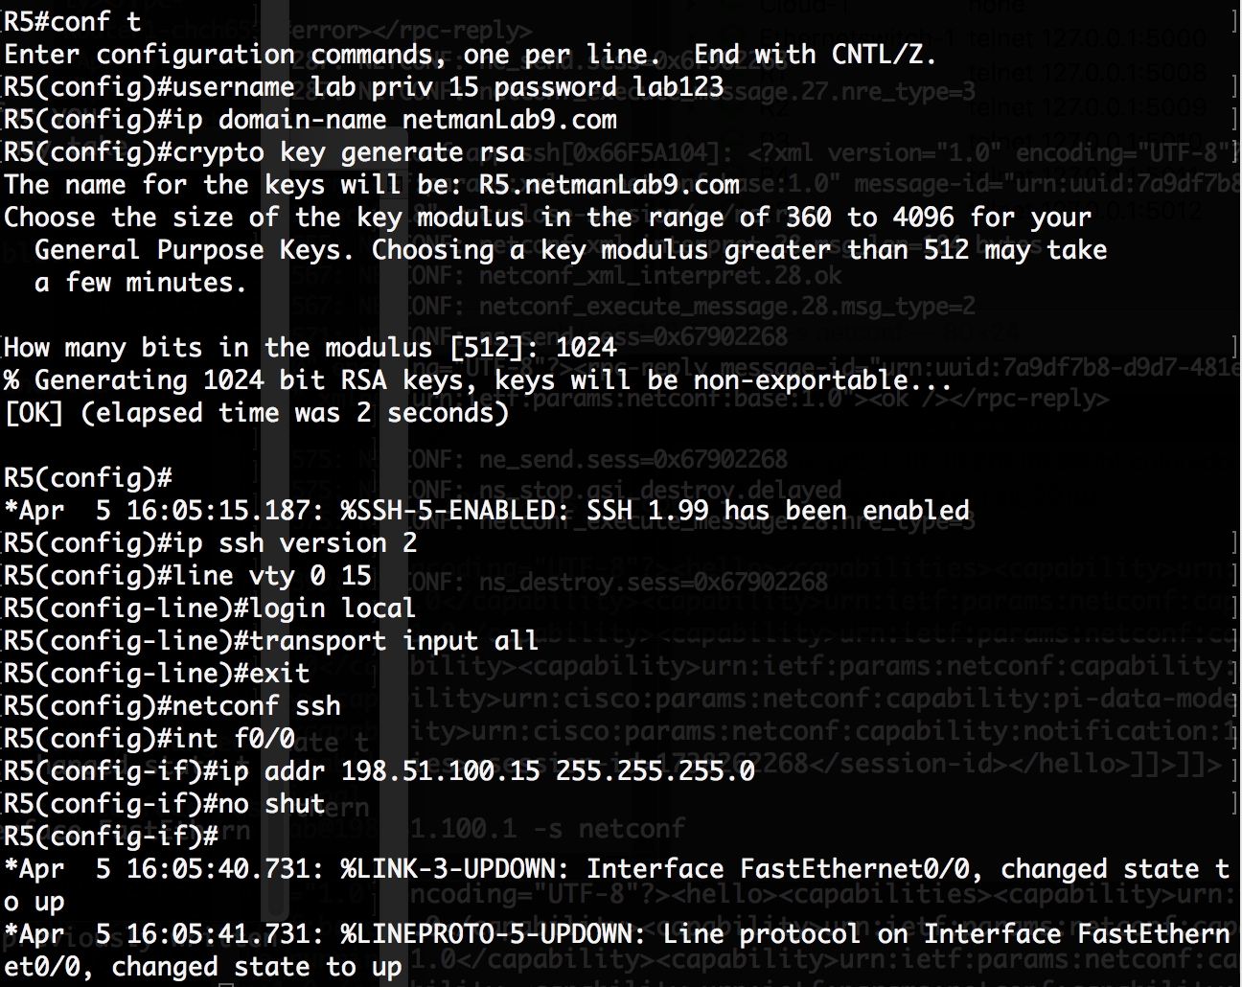

Final result:

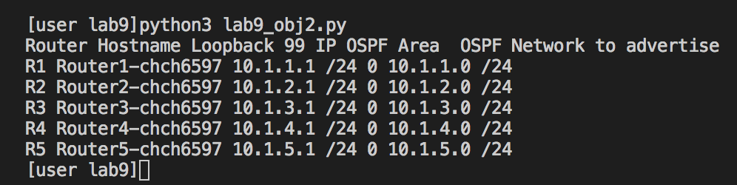

# Objective 3: Troubleshooting

1. Wget a router .cfg file from this link – <http://172.20.74.202/R1.cfg> [Accessible only from the campus network.]
2. Create a new project in GNS3 and create this exact topology – use router image c7200 and connect its FastEthernet0/0 interface to VM’s tap adapter.
3. Before starting the devices (i.e. pressing the green play button), import the downloaded .cfg file by right-clicking on the router and selecting Import config.



1. The objective is to make NETCONF work for this router. Write down the steps you followed to get it working. [**20 points**]

* Username netman priv 15 password netman
* Crypto key generate rsa [choose 1024 for option]
* Ip ssh version 2
* Fix ip address of f0/0 to 198.51.100.1 by doing ip addr 198.51.100.1 255.255.255.0
* Inside of f0/0, do ‘no ip access-group 1 in’, ‘no ip access-group 100 out’, and ‘no shut’
* (global config): No access-list 1
* (global config): No access-list 100
* (global config): netconf ssh
* (global config): line vty 0 15
* (global config): login local
* (global config): transport input all

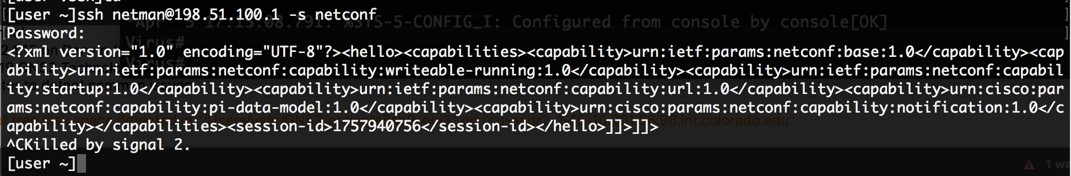

# Objective 4: NETCONF-YANG

1. For this objective you need to use a new VM which can be downloaded from - <https://drive.google.com/file/d/10uq_AhkbOixwMudVm07JmdMXaCkw_e15/view?usp=sharing>. Extract the .7z file.
2. This VM needs to be installed in a VMware based hypervisor (Workstation Pro or Player). You should have received an email from the Department of Computer Science when you started school containing the license you could use to download VMware products. Please use that code to download Workstation Pro. If you are not able to do it, you can use the trial version of Workstation Player from - <https://www.vmware.com/products/workstation-player/workstation-player-evaluation.html>.
3. Click the .vmx file to import it into VMware.
4. Use Cisco XR router image installed in GNS3 for this objective.

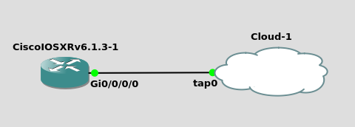

1. Enable NETCONF-YANG over SSH on the Cisco XR. Paste a screenshot of the output of ‘**sh netconf-yang clients**’, indicating a successful NETCONF connection [NC version should not be unknown]. [**10 Points**]

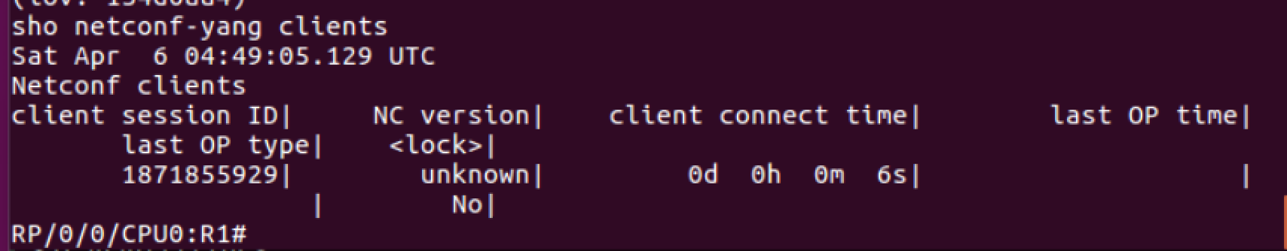

Netconf configuration steps:

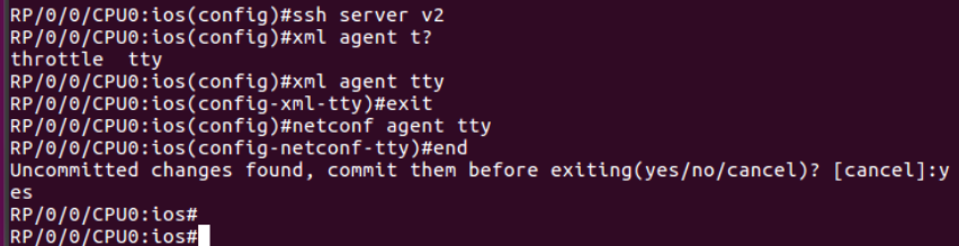

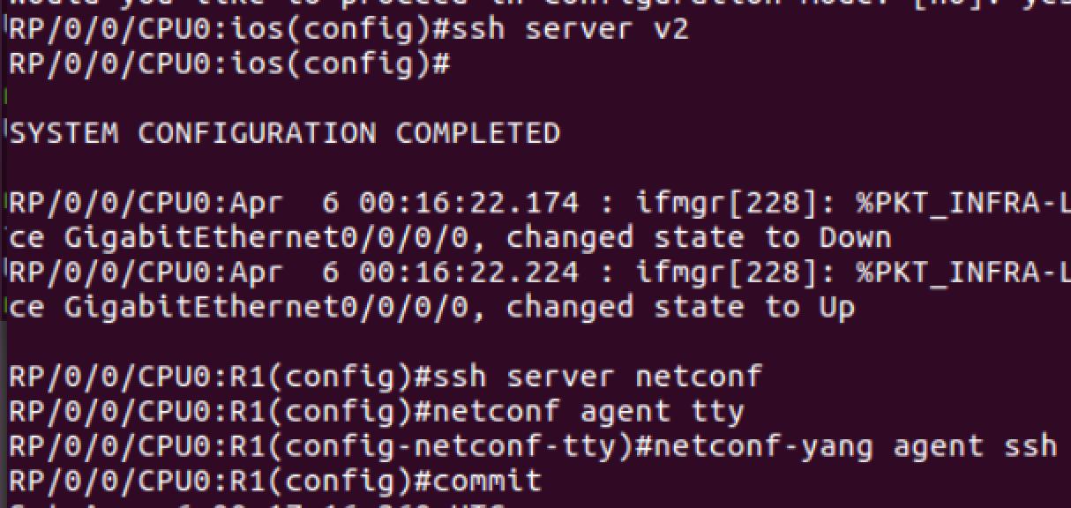

Enable g0/0/0/0 interface:



Enable ssh version 2:

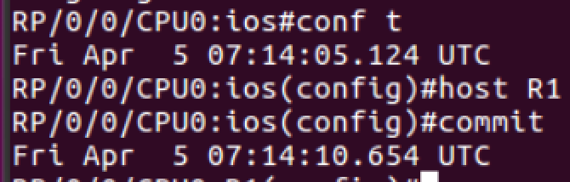

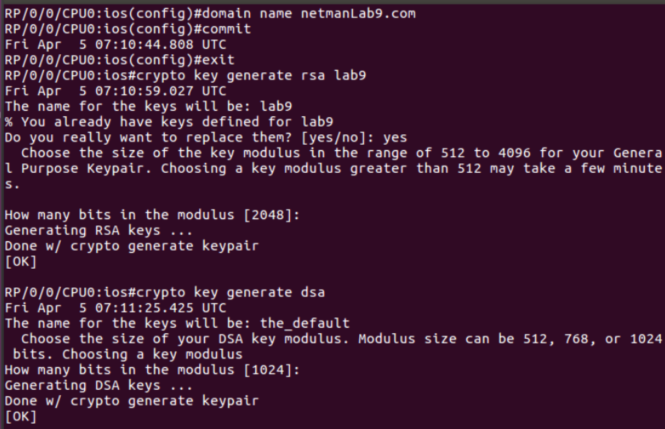

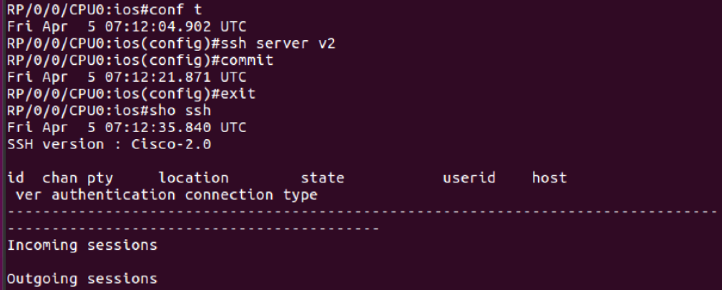







SSH password: lab

1. Use ncclient to complete the below objectives – [**15 Points**]
   1. Change hostname of router to ‘Lab9 XR’,
   2. Configure an access list on the router’s Gi0/0/0 interface to allow inbound traffic only from the host VM’s IP, and
   3. Create a loopback interface and assign it an IP of 10.11.12.13/32.

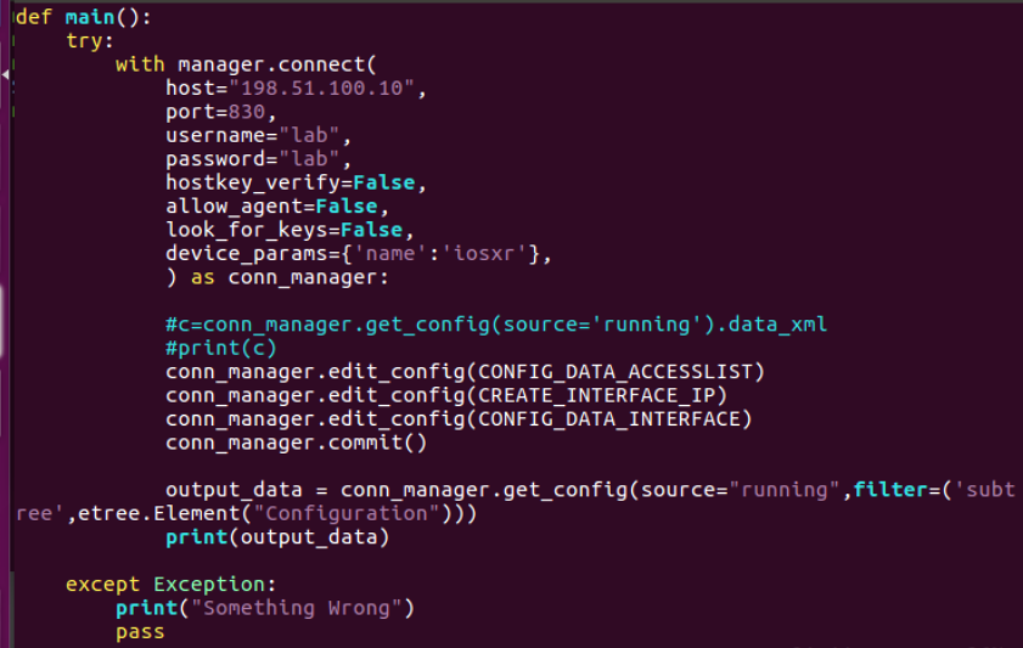

# Objective 5 – Report Question [5 Points]

1. In your opinion, what are the advantages of using data models such as YANG or YAML in network automation?

Netconf makes the implementation for configuration and fetch it a lot of easier. Besides, it also has provision to undo any changes. Netconf also has its own security mechanism.

1. Out of all the network automation tools you used (Netmiko, NAPALAM, Ansible, NETCONF, etc.), which one is your favorite and why?

Personally, I still prefer Netmiko because it’s the tool I’m most familiar with. It’s crazy easy to use, everything depends on how your Python implementation is. Ansible and Netconf are still new to me, but I’d love to keep using them and get more familiar with because they both are popular in industry nowadays. We need to keep up with the real-world progress.

# Total Score = ________________/185

References:

1. <https://www.cisco.com/c/en/us/td/docs/ios-xml/ios/cns/configuration/xe-3s/cns-xe-3s-book/cns-netconf.html>

2. <https://www.cisco.com/c/en/us/td/docs/ios-xml/ios/cns/configuration/15-mt/cns-15-mt-book/netconf-sshv2.html>